FIELD REPORT
Introduction
- Place: LORO HC III
- Location: Loro, Oyam district
- Date of visit: 25th August 2026
- General observations
The asset verification exercise was conducted at the health facility with support from the facility in charge and staff. The facility is a Health Centre III located within a trading center and reportedly experiences a high patient turnout. The facility staff indicated that the UGIFT-supported equipment has contributed to improved service delivery, particularly by strengthening the facility’s capacity to diagnose and manage patients.
2. Asset verification and documentation
The facility did not have a comprehensive official asset register available for the verification exercise. The inventory book was the main facility-level record available and was used to support the identification and verification of assets. The inventory book records the status of items and is periodically updated, with the facility in charge signing the records thereafter.
All UGIFT-supported assets were not engraved or marked with project-specific identification. This made it difficult to independently distinguish UGIFT-supported assets from other similar assets at the facility. Identification of UGIFT assets relied primarily on the available inventory records and information provided by facility staff.
Special notes
Staff Awareness of UgIFT Assets
- The current facility In-Charge reported that, having recently assumed the position, she does not have a clear understanding of which assets were provided under the UgIFT program and which were acquired through other sources. Her knowledge of the UgIFT-supported assets is largely based on information shared by staff who were present at the facility when the items were delivered.
- Due to limited documentation and her recent appointment, the In-Charge expressed low confidence in her ability to independently identify and account for all UgIFT assets at the facility. She noted that access to the original delivery records, asset lists, and other supporting documentation would help the facility establish a clear record of the items received under the program and support proper accountability.
- None of the assets are engraved
The table below illustrates some physical status of the verified assets with photographic evidence.
Table XXX: Physical verification photos
LORO HC III SIGN POST | 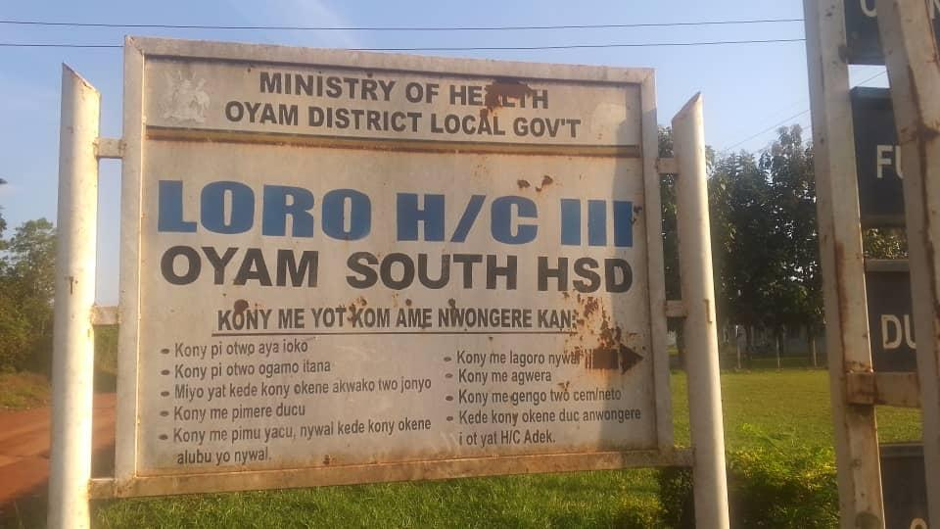
FRONT VIEW OF MATERNITY BLOCK | 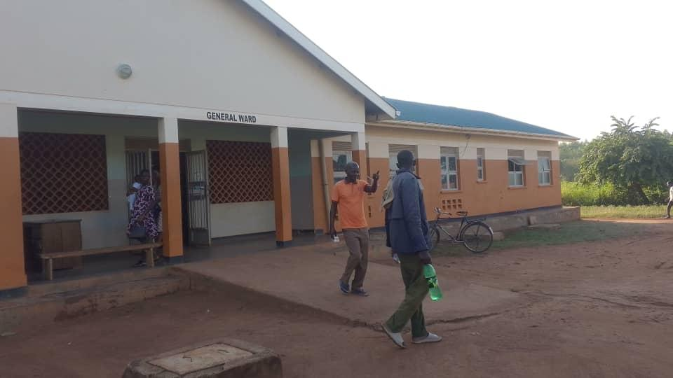
BACK VIEW OF MATERNITY BLOCK | 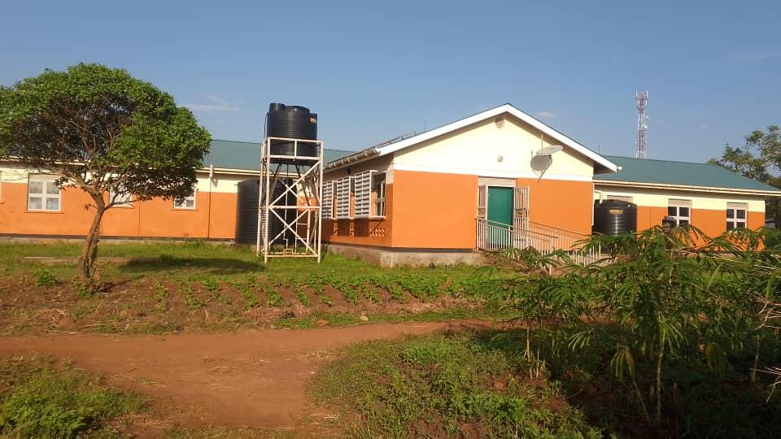
PATIENT LATRINES (TYPICAL 3 STANCE PIT LATRINE BLOCK) | 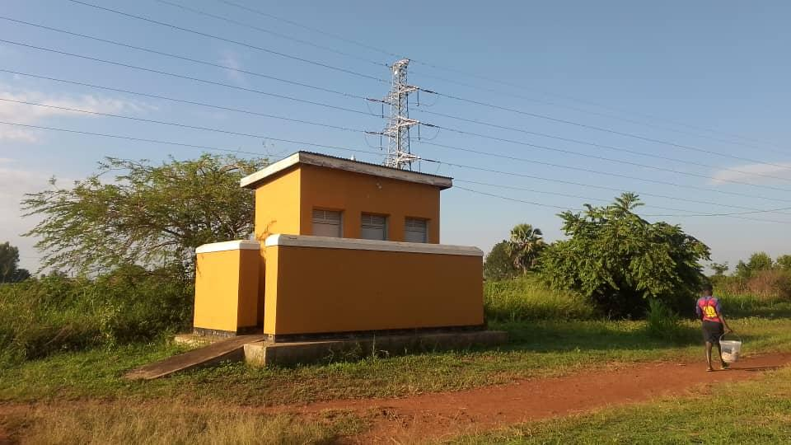
WATER TANKS SUPPLYING THE MATERNITY BLOCK | 